**Chapter 5**

**Multiple Integration**

**5.5 Triple Integrals in Cylindrical and Spherical Coordinates**

**Section Exercises**

**In the following exercises, evaluate the triple integrals  over the solid.**

241. , 

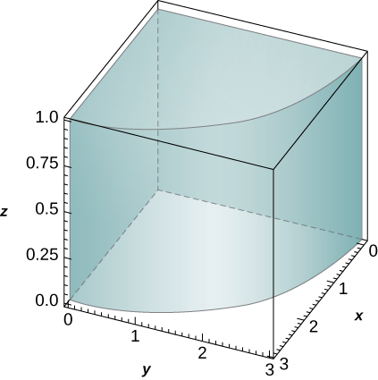

Answer:

243. , 

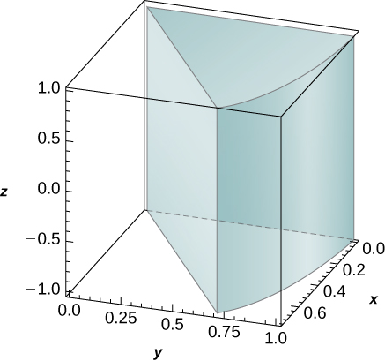

Answer: 

245. , 

Answer: 

247.

1. Let  be a cylindrical shell with inner radius , outer radius , and height , where  and . Assume that a function  defined on  can be expressed in cylindrical coordinates as , where  and  are differentiable functions. If  and , where  and  are antiderivatives of  and , respectively, show that 
2. Use the previous result to show that , where  is a cylindrical shell with inner radius **, outer radius , and height.

Answer: This is a proof; therefore, no answer is provided.

**In the following exercises, the boundaries of the solid  are given in cylindrical coordinates.**

1. **Express the region in cylindrical coordinates.**
2. **Convert the integral to cylindrical coordinates.**

249. *E* is bounded by the right circular cylinder the -plane, and the sphere .

Answer: a. ; b. 

251.  is located in the first octant and is bounded by the circular paraboloid , the cylinder , and the plane.

Answer: a. ; b.



**In the following exercises, the function  and region  are given.**

1. **Express the region  and the function  in cylindrical coordinates.**
2. **Convert the integral into cylindrical coordinates and evaluate it.**

253.  

Answer: a. , b. 

255. , 

Answer: a.,  b. 

**In the following exercises, find the volume of the solid  whose boundaries are given in rectangular coordinates.**

257.  is above the, inside the cylinder , and below the plane.

Answer: 

259.  is bounded by the circular cone and .

Answer: 

261.  is located inside the cylinder and between the circular paraboloids  and .

Answer:

263.  is located outside the circular cone  and between the planes  and .

Answer: 

265. **[T]** Use a computer algebra system (CAS) to graph the solid whose volume is given by the iterated integral in cylindrical coordinates Find the volume of the solid. Round your answer to four decimal places.

Answer: 

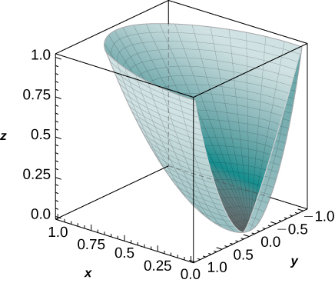

267. Convert the integral  into an integral in cylindrical coordinates.

Answer: 

**In the following exercises, evaluate the triple integral  over the solid.**

269. , 

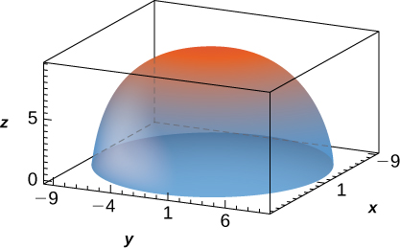

Answer:

271. ,  is bounded above by the half-sphere  with  and below by the cone 

Answer:

273. Show that if  is a continuous function on the spherical box , then 

Answer: This is a proof; therefore, no answer is provided.

275.

1. Let  be the region between the upper concentric hemispheres of radii *a* and *b* centered at the origin and situated in the first octant, where . Consider *F* a function defined on *B* whose form in spherical coordinates  is . Show that if  and , then  where  is an antiderivative of  and  is an antiderivative of
2. Use the previous result to show that , where  is the region between the upper concentric hemispheres of radii ** and ** centered at the origin and situated in the first octant.

Answer: This is a proof; therefore, no answer is provided.

**In the following exercises, the function  and region  are given.**

1. **Express the region  and function  in cylindrical coordinates.**
2. **Convert the integral  into cylindrical coordinates and evaluate it.**

277.  

Answer: a. ,; b. 

279. ; 

Answer: a. ; ; b. 

**In the following exercises, find the volume of the solid  whose boundaries are given in rectangular coordinates.**

281. 

Answer: 

283. Use spherical coordinates to find the volume of the ball that is situated between the cones 

Answer:

285. Convert the integral  into an integral in spherical coordinates.

Answer: 

287. **[T]** Use a CAS to graph the solid whose volume is given by the iterated integral in spherical coordinates Find the volume  of the solid. Round your answer to three decimal places.

Answer: 

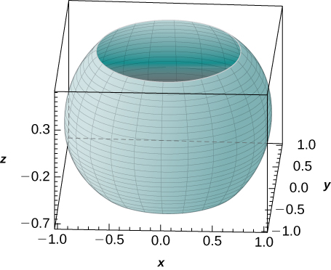

289. **[T]** Use a CAS to evaluate the integral where  lies above the paraboloid  and below the plane.

Answer: 

291. Express the volume of the solid inside the sphere  and outside the cylinder  as triple integrals in cylindrical coordinates and spherical coordinates, respectively.

Answer: ; 

293. The power emitted by an antenna has a power density per unit volume given in spherical coordinates by ,

where  is a constant with units in watts. The total power within a sphere of radius  meters is defined as . Find the total power.

Answer:  watts

295. A charge cloud contained in a sphere  of radius *r* centimeters centered at the origin has its charge density given by , where . The total charge contained in  is given by  Find the total charge.

Answer: 

**Student Project**

**Hot Air Balloons**

1. Find the volume of the balloon in two ways.

1. Use triple integrals to calculate the volume. Consider each part of the balloon separately. (Consider using spherical coordinates for the top part and cylindrical coordinates for the bottom part.)
2. Verify the answer using the formulas for the volume of a sphere, , and for the volume of a cone, 

Answer: Let *E* denote the three-dimensional region we have used to model the balloon. Breaking this region into two pieces, let  denote the top part of the balloon and let  denote the bottom part of the balloon.

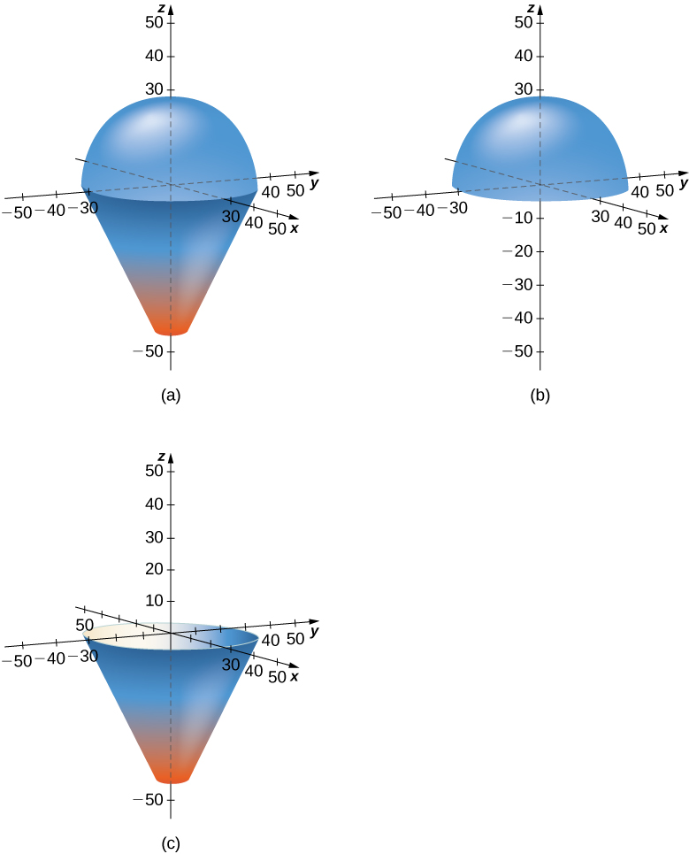

(a) The 3-dimensional region *E*, representing the entire balloon. (b) The region , representing to top part of the balloon. (c) The region , representing the bottom part of the balloon.

Then



Looking at each of the integrals on the right side separately, we see that

The volume of the top part of the balloon is  cubic feet. Now, turning to the bottom part of the balloon we see that



Use *u*-substitution on the inside integral with  to get



The volume of the bottom part of the balloon is  cubic feet. Then the volume of the whole balloon is



For part b., check using the volume formulas to get the same answers.

3. Find the average temperature of the air in the balloon after the pilot has activated the burner for  seconds.

Answer: To find the average temperature, we need to calculate



Looking at the integrals separately, we get



and



Then the average temperature in the balloon is



This file is copyright 2016, Rice University. All Rights Reserved.